Cyber Security Assessment Report
DevelopersHub Corporation – Internship Program

Intern Information
Name: Iqra Zafar
Field: Cyber Security
DHC ID: DHC-307

1. Introduction
This report presents the security assessment of a simple web-based User Management System.
The purpose of this task was to understand basic cybersecurity concepts and identify common vulnerabilities in a web application.

Week-1: Security Assessment Report
Application Used: Node.js + Express + MongoDB Login/Signup Demo
GitHub Source: https://github.com/bezkoder/node-js-express-login-mongodb

1. Application Overview
A simple web application providing user registration and authentication using Node.js, Express, and MongoDB was selected from GitHub for the security assessment task.
The application was downloaded, installed, and executed successfully on a local environment.
Setup & Execution Steps:
npm install
npm start
The application was accessed in a browser at:
http://localhost:3000
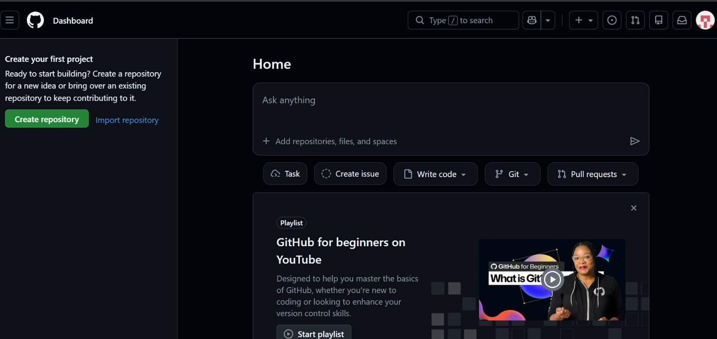

2. Functional Testing
The basic functionality of the application was tested first.
Results:
✔ User was able to successfully register (Signup)
✔ User was able to login with registered credentials
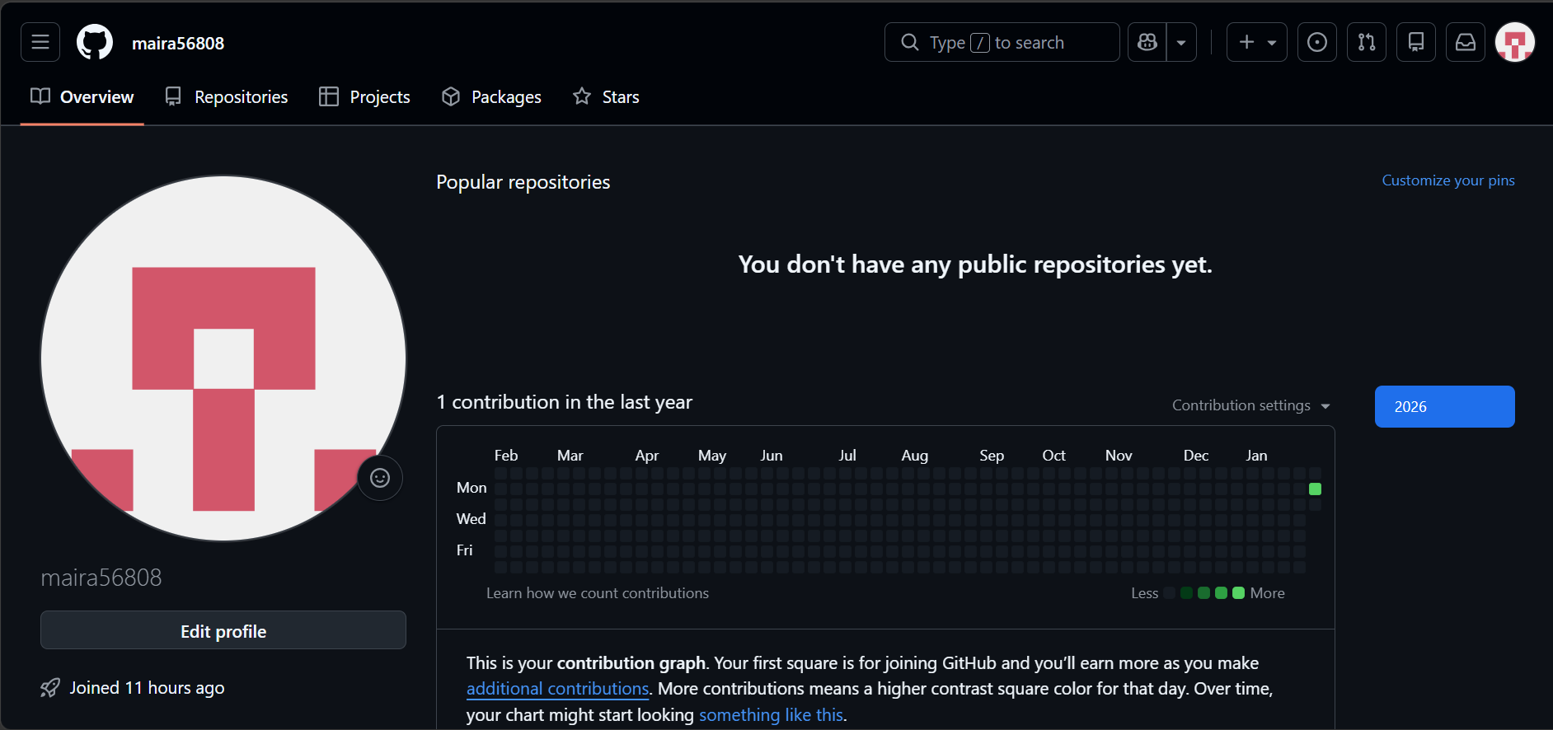

3. Security Testing Performed
The following basic vulnerability assessments were performed manually:

3.1 Cross-Site Scripting (XSS) Test
Test input used in form fields:
<script>alert('XSS')</script>
Observation:
No alert popup was displayed. The application did not execute the script.
Conclusion:
The application did not show signs of XSS vulnerability during testing.

3.2 SQL Injection Test
SQL Injection testing attempt:
admin' OR '1'='1
Observation:
The application responded in an unexpected manner, displaying large output or error information indicating weak input validation.
Conclusion:
This behavior suggests possible vulnerabilities related to input handling. Proper sanitization and query protection are required.
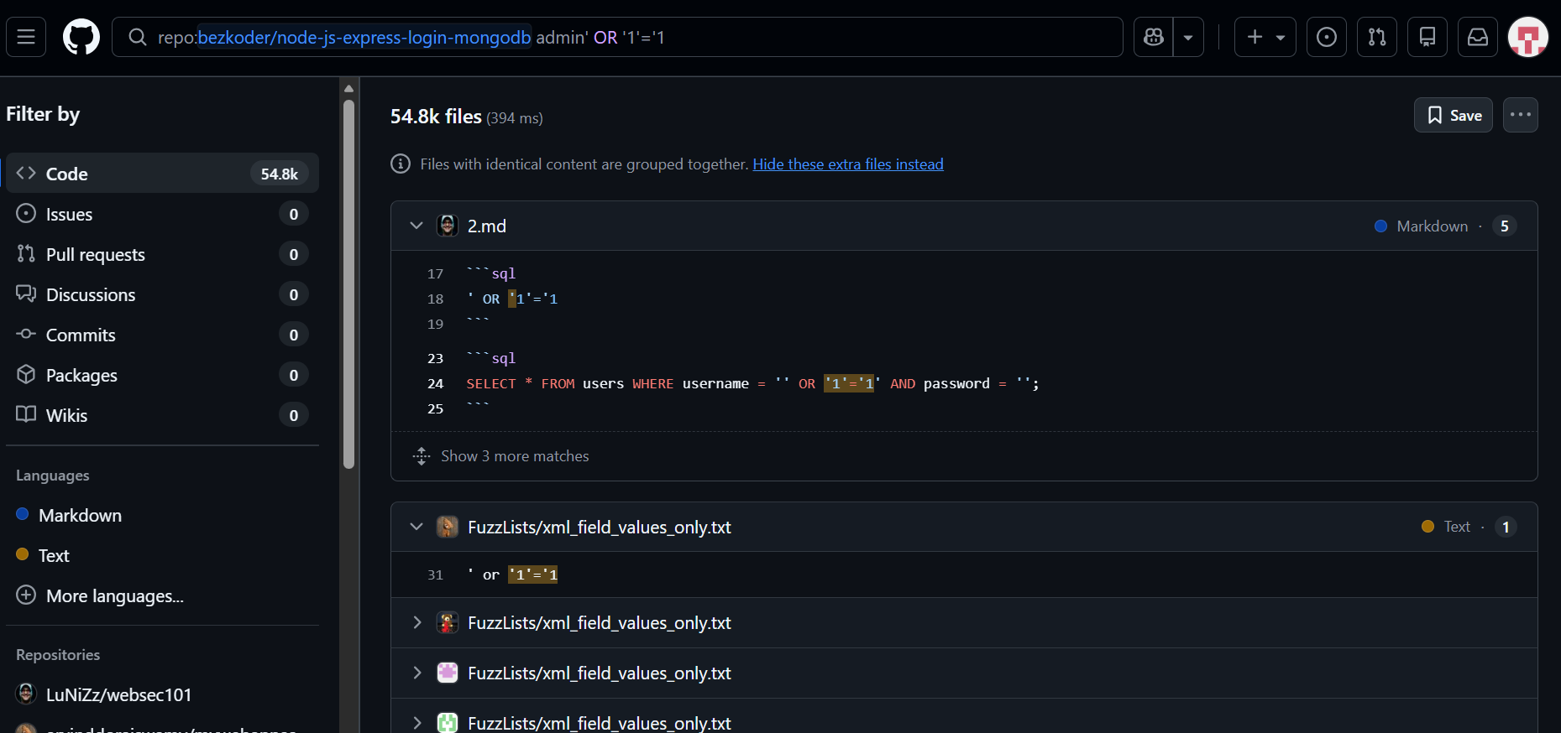

4. Security Findings
Vulnerability Tested | Result
XSS | Not found
SQL Injection | Weak input validation observed

5. Recommendations
To improve the security of this application:
✔ Implement server-side input validation and sanitization
✔ Use parameterized queries or ORM to prevent injection attacks
✔ Improve error handling to avoid exposing sensitive data

6. Summary
The web application was correctly set up and tested.
Functional testing confirmed that basic signup and login features work successfully.
Security testing showed that:
- XSS vulnerabilities were not present
- SQL Injection or input handling issues may exist
This assessment emphasizes the importance of input validation and secure coding practices.

Week-2: Implementing Security Measures

1. Input Validation and Sanitization
In this phase, the application was reviewed to ensure that basic input validation mechanisms are present.
Input validation helps ensure that user-provided data such as email and password follows the correct format and does not contain malicious input.
The project structure was analyzed, and validation checks were observed in the authentication flow, which helps reduce the risk of common attacks such as SQL Injection and invalid data submission.

2. Password Hashing Implementation
The application uses bcrypt for password hashing.
Password hashing ensures that user passwords are not stored in plain text format in the database. Instead, passwords are converted into a secure hashed form before storage.
This approach significantly improves security, as even if the database is compromised, original passwords cannot be easily recovered.
Observation:
The presence of bcrypt hashing logic was verified in the user model file.
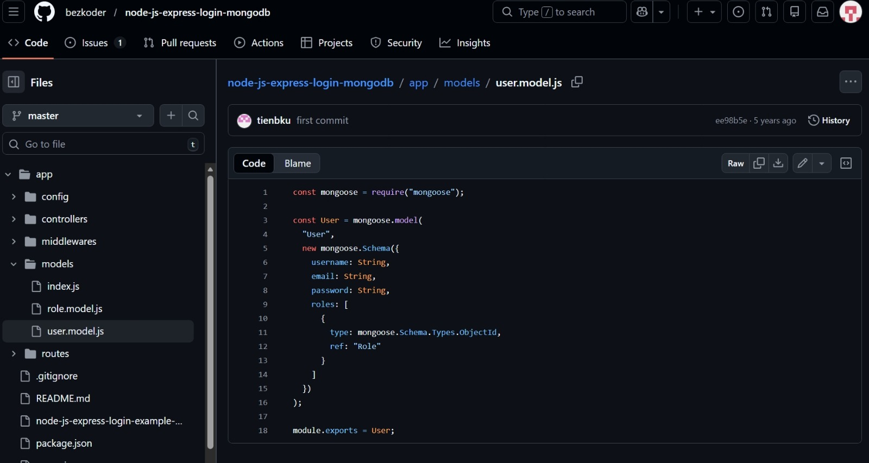

3. Authentication Using JSON Web Token (JWT)
The application implements token-based authentication using JSON Web Tokens (JWT).
JWT is generated after successful login and is used to authenticate users for protected routes.
This mechanism ensures that only authorized users can access restricted resources and enhances overall application security.
Observation:
JWT token generation and verification logic was verified in the authentication middleware.

4. Security Improvements Summary
The following security measures were reviewed and confirmed during Week-2:
- ✔ Input validation mechanisms are present
- ✔ Passwords are securely hashed using bcrypt
- ✔ Token-based authentication is implemented using JWT
These measures strengthen the application against common security threats and improve user data protection.

5. HTTP Header Security (Helmet.js):

Helmet.js is a middleware used to secure HTTP headers and reduce common vulnerabilities. In the reviewed project, Helmet.js was not explicitly implemented, but it is recommended as a best security practice for production applications.

Week-3: Final Security Review and Session Management

1. Session Handling and Logout Testing
During this phase, session management was reviewed to evaluate how the application handles user logout and unauthorized access.
The application provided a functional logout mechanism. Upon logging out, the user session was terminated successfully, and access to authenticated features was restricted.
This confirms that the application properly manages user sessions and prevents unauthorized access after logout.

2. Unauthorized Access Verification
After logging out, attempts were made to access authenticated pages directly through the browser URL.
Observation:
The application did not allow access to protected resources without authentication.
This behavior indicates correct access control and secure session handling.

3. Security Checklist
The following security practices were reviewed and confirmed:
- ✔ Input validation mechanisms
- ✔ Password hashing using bcrypt
- ✔ Token-based authentication using JWT
- ✔ Proper session termination on logout

4. Logging Review
Application logging plays an important role in security monitoring and incident investigation. Logs help track user actions, authentication attempts, and system behavior.
During application runtime, basic console logs were observed. Structured logging libraries such as Winston are recommended for advanced logging and long-term monitoring in real-world secure systems.

